Costume Design Handbook
Ardrey Kell High School
2025-26 School Year
Application due by Thursday, July 17.. Make a copy of this form and email this, along with your renderings, to Ms. Calvert.

Ms. Calvert: ashlis.calvert@cms.k12.nc.us
There are two choices for costuming this year:
- If you would like to be considered as a costume designer (this means you make 75% of the clothing and are eligible for a Blumey nomination) check the COSTUME DESIGNER box below.
- If you wish to be considered as a costumer (you oversee all costumes but may buy, pull or borrow clothing. You would NOT be eligible for a Blumey nomination) check the COSTUMER box.
I am applying for:
- COSTUME DESIGNER
- COSTUMER
Role
The role of the costume designer is to fully conceptualize and oversee the construction of costumes for a production. This includes garments, accessories, and hair/makeup. The designer will work closely with the artistic directors and production team to create a cohesive look for each character. The costumer’s role is the same except there is less outright construction, although some may be included. Sewing knowledge is a necessity for both roles.
Responsibilities
1. Read and analyze the script
2. Explore the setting and themes of the story and represent these ideas onstage
3. Consistently converse with director to create and alter designs
4. Scheduling flexibility 3-4 weekdays, as well as a few possible Saturdays
5. Uphold production expectations and timelines by mentoring peers
6. Maintain a detailed and accurate budget of all materials purchased
7. Lead and manage a student team to make visions come to life
8. Work backstage during run of the production

Guys and Dolls

Setting:
A specific version of New York City inspired by Damon Runyon’s stories involving gamblers, mobsters and showgirls. Set in the 1930s.

Summary:
Guys and Dolls is about a couple of big city gamblers and the women who love them. It tells the overlapping stories of high-roller Sky Masterson, who falls in love with mission worker Sarah Brown, and lovable rapscallion Nathan Detroit, engaged for 14 years to Miss Adelaide, a headliner at the Hot Box Club. Nathan runs a famous floating crap game, and an ongoing plot line involves his quest for a safe place for the game as Adelaide continues her quest to convince him to marry her. Meanwhile, Sarah, mistakenly believing that Sky set up an illegal game at the mission, tries to fight her affection for the charismatic crapshooter.

Main Character Descriptions:

Sky Masterson
Sky Masterson is the ultimate Broadway gambler; he's slick and charming. He has a soft spot for Sarah Brown.

Sarah Brown
Sarah Brown is the "girl next door" with an adventurous side that's waiting to escape. She is gently authoritative, the mirror opposite of Sky. Sky is her weakness. Sarah is about substance as much as Sky is about style.

Nathan Detroit
Nathan Detroit is the lead gambler and the guy to know. He is always setting up games for the gamblers and in charge and should have great comedic timing. His presence must draw the focus in any scene. Nathan's big secret is that he wants to marry Adelaide; he just can't bring himself to admit it.

Miss Adelaide
Miss Adelaide is classy, sassy, funny, and FULL of personality and pizzazz. She is a dancer and performer and dresses in a flashy way..
INSPIRATIONAL IMAGES:
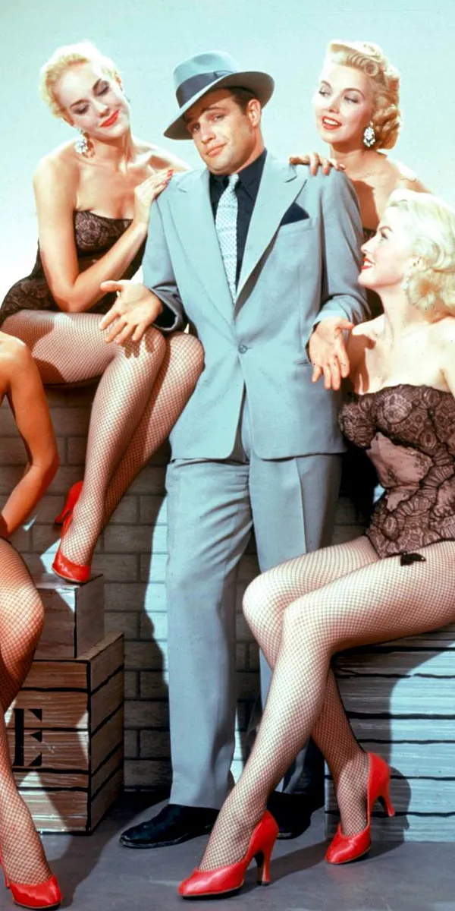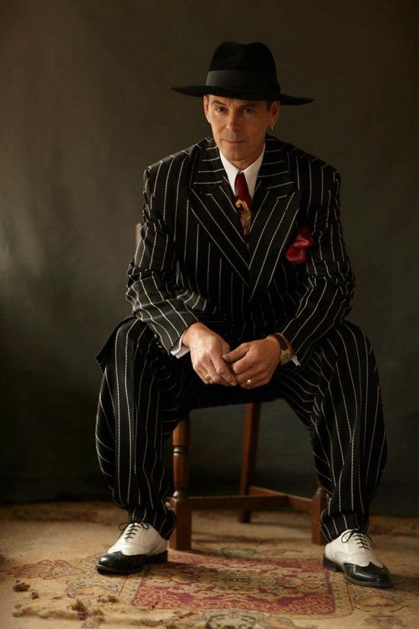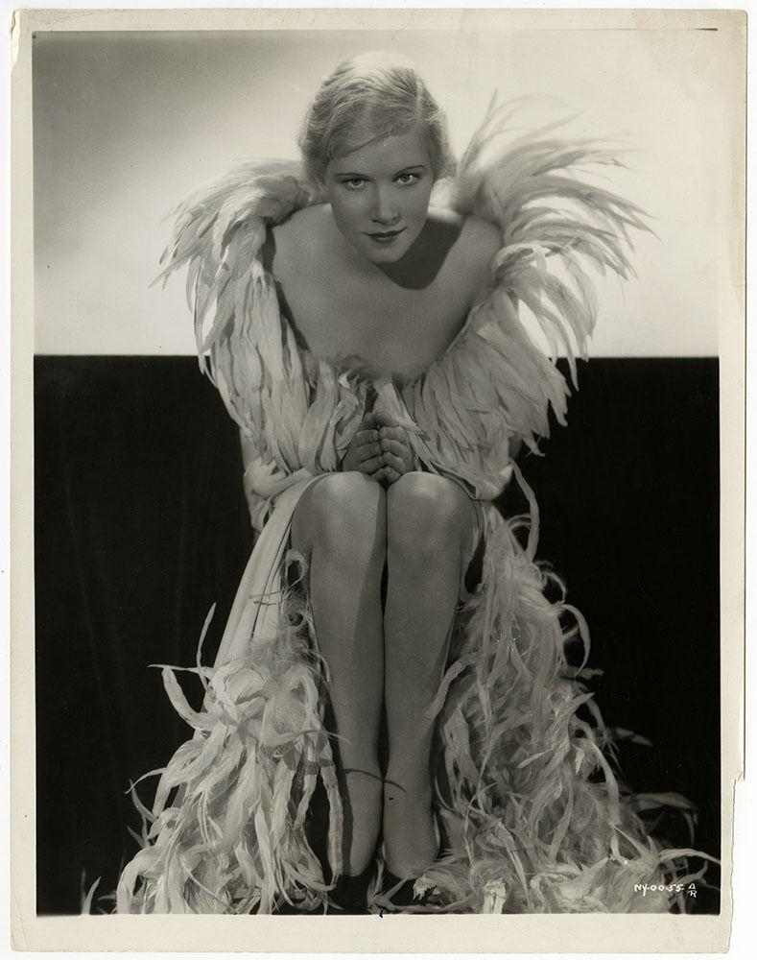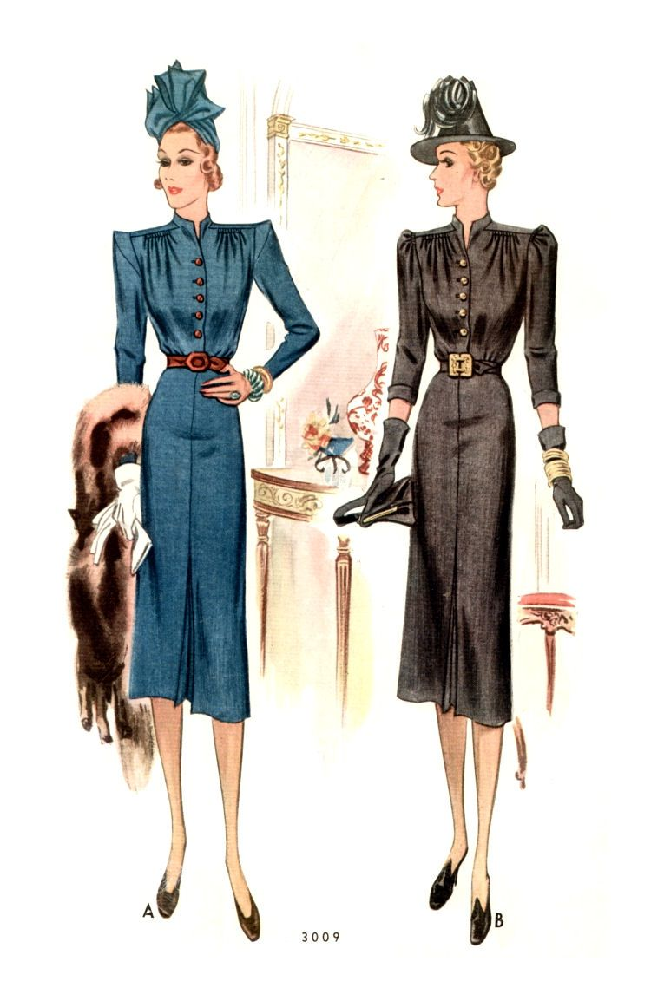
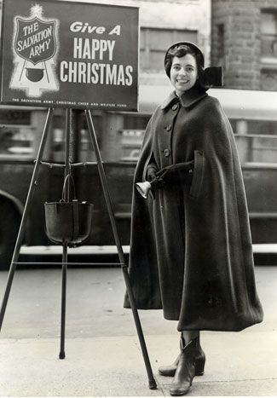
SALVATION ARMY UNIFORM
Main colors of red, white, black and gold. Hot pink for Adelaide. Characters can have a “signature color” or colors if you wish- explain your ideas and concepts below.

Fill out the following schedule with your general availability. Remember that you must be available, for the most part, 2-4 days on weekdays from 2:45-4:30, and have some Saturdays. Please be as thorough and as honest as possible.
Day Recurring Conflicts
Monday
Tuesday
Wednesday
Thursday
Friday
Saturday

Read the following questions regarding the costume design process and respond.

1. Describe what your scheduling plan might look like to prepare all costumes and accessories at least two weeks before the production’s opening. What types of pieces would take precedence and be your initial focus? Why?

2. Describe your plan to get peers to work efficiently as a team, with a cohesive vision and a constructive use of time.
3. Scenario: It is busy, and there are a million things that need your attention. You tell a student on the sewing team to hem a skirt. They tell you that they have never done that before. Someone else comes up to you to ask you a question, and you also have a project that you are working on. Do you put the first student on a simpler task, or show them how to hem? Justify your response.

4. Describe the process of completing the following tasks, from start to finish. Include what tools would be best for the job if applicable.
1. Creating a quick change dress.
2. Deciding whether to buy, pull, or build a costume.

3. Organizing costumes in the backstage area before a show.

**(Only if you are applying for Costume Designer)5. What are some considerations to take into account when constructing costumes for the stage? List as many as you can think of..

6. Provide a 3-5 sentence justification for the choices made in your costume rendering(s) as they apply to the production you chose. Also list what types of fabric will be used in this garment(s). Include justifications for the colors, styles, the current state of the clothing (dirty, old, new, clean, etc.), themes, flexibility for the actor, etc.
Rendering Requirements
Digitally or by hand, create a front view, colored rendering of each of the four main characters from Guys and Dolls. Submit this as a separate document in your email. Remember that most designers will color renderings with colored pencil or watercolor if they are hand drawn, so as to easily show different gradients. Be as neat as possible! Most renderings are 8 inches tall, but as long as they are large enough to see detail, you can make them whatever size you would like for the time being. Feel free to hand draw your own figure or use a template. There is no need to draw facial features on the figure, but please include any accessories the character might use to accentuate their garment.

Costume Design Selection Rubric

Category | 0 | 5 | 10
Use of Textiles | Costume rendering does not use a mix of textiles and is not the appropriate fabric for this garment. | Costume rendering accomplishes only one of the following: uses a mix of textiles and is the appropriate fabric for the garment. | Costume rendering uses a blend of textiles and is appropriate for the style and flow of garment with ample movement for the actor.
Visual Interest | Costume color scheme and detailing do not match the production style or are lacking points of interest. | Costume possesses only one of the following: 1. A pleasing and notable scheme and 2. points of interest | Costume possesses both a pleasing and notable color scheme as well as several points of interest.
Adaptability/Logistics | Costume does not match the time period/setting, is poorly executed, or does not meet the scene in which it appears. | Costume meets one of the following requirements: matches the time period/setting, or meets the need of the scene. | Costume makes sense for the time period/setting, and meets the needs of the scene (actor movement, special effects.)
Originality | Costume replicates productions credited to other designers and lacks depth and added detail. | Costume is only somewhat indicative of other productions but lacks depth and detail. | Costume is completely original, showcases attention to detail, and shows personality and status of character.
Responses | Responses to questions 1-6 are  not thought out,  and/or are missing  responses entirely. | Responses to questions 1-6 are mostly thought out and logical (at least ⅗ questions) | Responses to questions 1-6 are fully thought out and logical.

